# 

TAPSIBOG ORDERING AND SALES SYSTEM

Project Documentation Submitted

To the Faculty of School of

Computing and Information Technologies

Of

Asia Pacific College



In Partial Fulfillment of the Requirements for the subject

Applied Projects 2 or Software Development

By:

Owen Ylaya

Kenneth Romero

Ron Eric Legaspi

Table of Contents

Project Title

Executive Summary

List of Figures, List of Tables, List of Notations

I. Introduction

1.1 Project Context

1.2 Purpose and Description

1.3 Objectives

1.4 Scope and Limitations

II. Review of Related Literature/Systems

III. Technical Background

IV. Methodology, Results and Discussion

4.1 Requirements Analysis

4.2 Requirements Documentation

4.3 Design of Software, Systems, Product, and/or Processes

4.4 Development and Testing, where applicable

4.5 Description of the Prototype, where applicable

4.6 Implementation Plan (Infrastructure/Deployment) where needed

4.7 Implementation Results, where applicable

4.8 Include discussion on conceptual design / system architecture/ block diagrams and algorithms

V. Conclusions and Recommendations

VI. Appendices

# Executive Summary

This Document was created to let the user know more about the system. The project was created for our current client, which is Tapsibog, was a small eatery before but grew to have many departments. The Project team is comprised of 3 students from Asia Pacific College. This three were tasked to do system for Tapsibog Ordering and Sales System after seeing how the existing system was. They have found some problems that need attention, this three people continued on developing the system. So far they are close to finishing it.

The Project team’s objective in creating this project was generally spin around the issue of viability and productivity. They made the framework to determine the issue our customer is confronting. This study is constrained to what they can create and come up for them. It concentrates on how they can help them improve their school much. The system features a function that helps the client organize its files and record. It also has a feature that lets the staff member access and input data in a database system.

Lastly the project runs on a Java programming language and HTML and in the local servers of XAMPP. The project is windows based operating system. The project is only exclusive to the Tapsibog eatery; it cannot be accessed outside of the business premises.

# List of Figures, List of Tables, List of Notations

EVENT TABLE

|  |  |  |  |  |  |
| --- | --- | --- | --- | --- | --- |
| Event | Trigger | Source | Use Case | Response | Destination |
| Admin inputs supply in inventory | Input and record supply details | Admin | Input Supply count in inventory | Recorded supply details in system | System |
| Customer orders a product | Receive and record order details | Customer | Record order details | Order details recorded in the system | System |
| Customer pays for his/her order | Receive payment | Customer | Get Payment | Compute payment from order price | System |
| New item quantity | Diminished product count | System | Diminish product quantity | Product quantity update | System |
| Admin manages system | Manage/View  Products | Admin | Manage/View  System | Changes are Saved | System |

USE CASE DIAGRAM

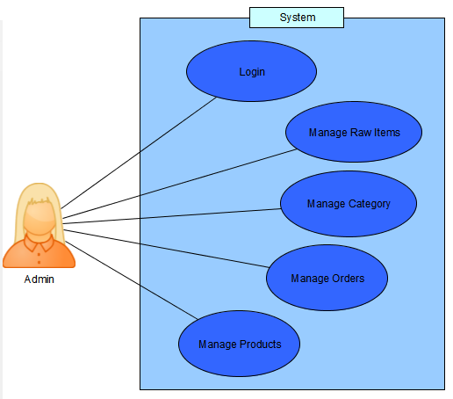

ERD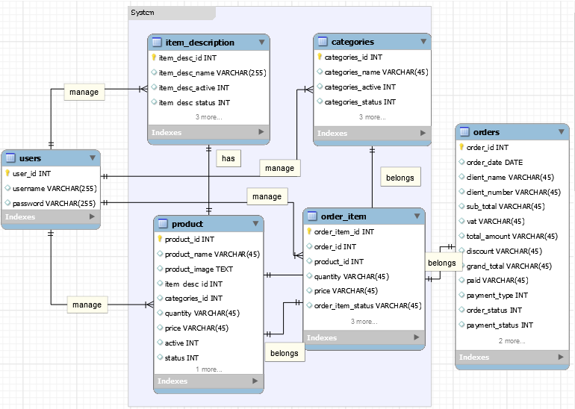

USE CASE DIAGRAM FULL DESCRIPTION

|  |  |  |
| --- | --- | --- |
| Use Case Name: | Input supply count in inventory | |
| Scenario: | Replenished goods are recorded in the system | |
| Triggering Event: |  | |
| Actors: | Admin | |
| Related Use Cases: | Create Order | |
| Stakeholders: | Admin | |
| Preconditions: | Exact number of raw Items must be inputted | |
| Postconditions: | Number of raw items are recorded inside the system | |
| Flow of Activities: | Actor | System |
| 1. login  2. “Add Raw Items”  3. Input item count | 3.1 Admin page will be shown |
| Exception Conditions: | No new raw items | |

|  |  |  |
| --- | --- | --- |
| Use Case Name: | Order details recorded in the system | |
| Scenario: | Customer’s available requests are recorded | |
| Triggering Event: | Receive and record order details | |
| Brief Description: | New order will be added to the system | |
| Actors: | Customer, Admin | |
| Related Use Cases: | Get payment | |
| Stakeholders: |  | |
| Preconditions: | Products must be available | |
| Postconditions: | New order is added to the order list | |
| Flow of Activities: | Actor | System |
| 1. login  2. Admin inputs order | 2.1 System stores order  2.2 Computes required payment. |
| Exception Conditions: | Customer cancels order  Incorrect data inputted | |

|  |  |  |
| --- | --- | --- |
| Use Case Name: | Get payment | |
| Scenario: | Customer pay the total amount of his/her order | |
| Triggering Event: | Customer pays order | |
| Brief Description: | Cashier receives payment | |
| Actors: | Customer, Cashier | |
| Related Use Cases: | New item quantity | |
| Stakeholders: | Customer, Admin | |
| Preconditions: | Cashier informs the customer the amount to be paid | |
| Postconditions: | Customer gives required amount payment | |
| Flow of Activities: | Actor | System |
| 2.1 Cashier informs the customer the amount to be paid  3. give change | 1. Compute for the amount  2. Display amount |
| Exception Conditions: |  | |

|  |  |  |
| --- | --- | --- |
| Use Case Name: | Diminish product quantity | |
| Scenario: | System will diminish product count by order details | |
| Triggering Event: | Update product quantity | |
| Brief Description: | System will diminish product quantity and raw items | |
| Actors: | System | |
| Related Use Cases: | Record order details | |
| Stakeholders: |  | |
| Preconditions: | Enter order details | |
| Postconditions: | Updated product quantity | |
| Flow of Activities: | Actor | System |
| 1. Input order details | 1. Record order details  1.1 Diminish product quantity |
| Exception Conditions: |  | |

|  |  |  |
| --- | --- | --- |
| Use Case Name: | Manage/View Inventory System | |
| Scenario: | Admin can Add, Delete, or Edit inside the system | |
| Triggering Event: | Manage Products, Categories, Raw Items | |
| Brief Description: | Admin can Add, Delete, or Edit the system and generate report | |
| Actors: | Admin | |
| Related Use Cases: |  | |
| Stakeholders: |  | |
| Preconditions: | Admin must be logged-in in the System | |
| Postconditions: | Admin can manage the inventory details | |
| Flow of Activities: | Actor | System |
| 1. login  2. Manage inventory  3. Save changes | 3.1 Changes are saved |
| Exception Conditions: |  | |

TIMING DIAGRAM

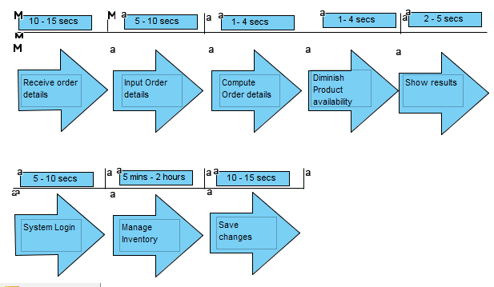

CLASS DIAGRAM

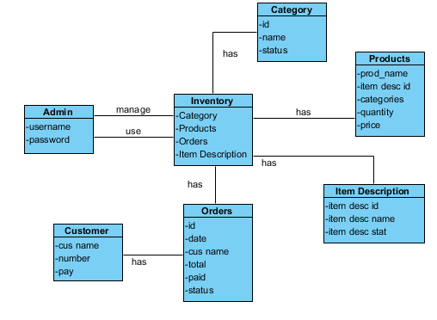

COMPOSITE STRUCTURE DIAGRAM

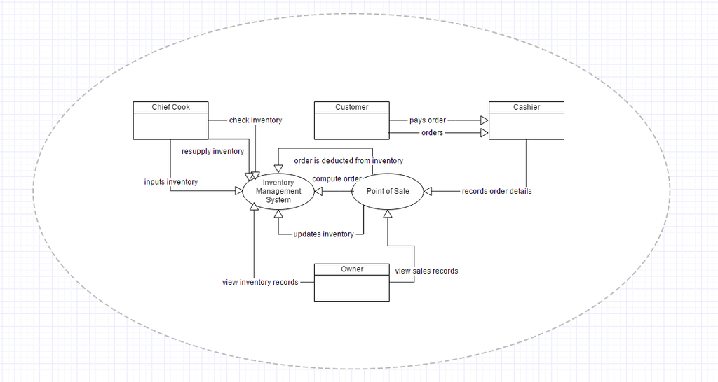

STATE MACHINE DIAGRAM

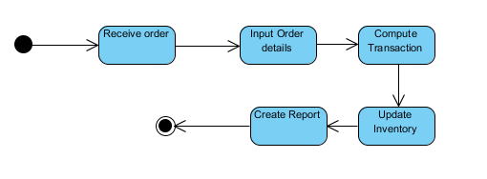

OBJECT DIAGRAM

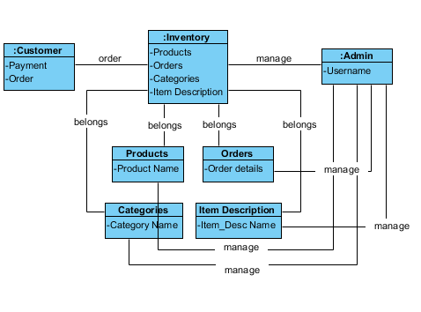

PACKAGE DIAGRAM

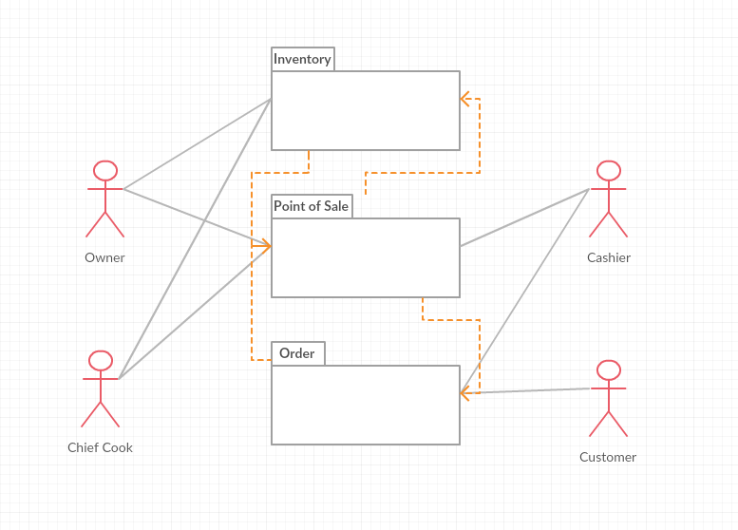

COMPONENT DIAGRAM

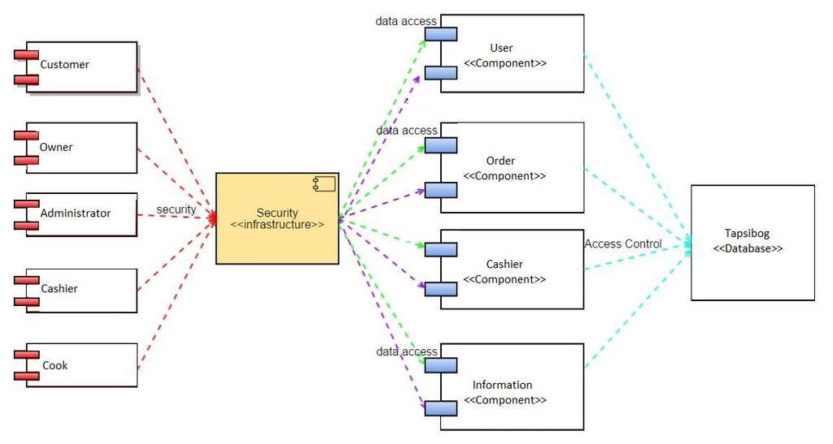

DEPLOYMENT DIAGRAM

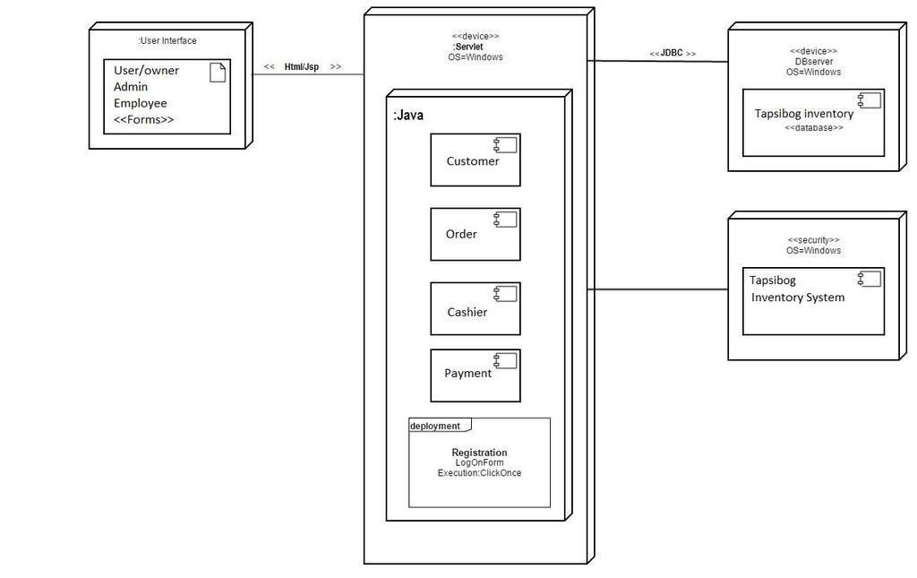

INTERACTION OVERVIEW DIAGRAM

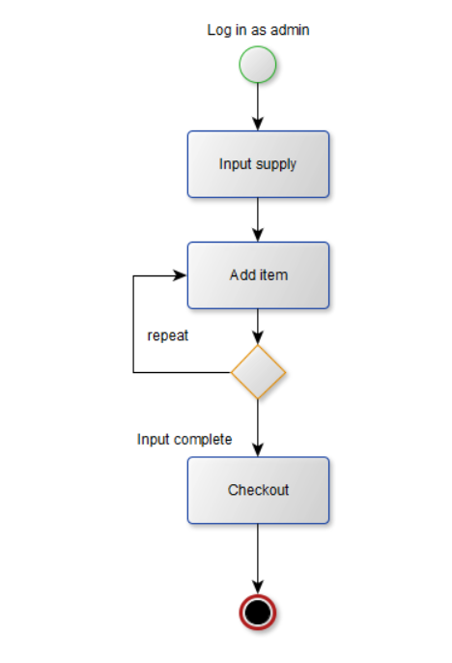

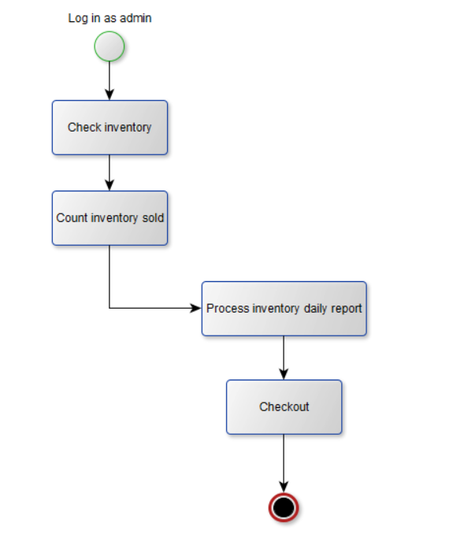

CONTEXT FLOW DIAGRAM

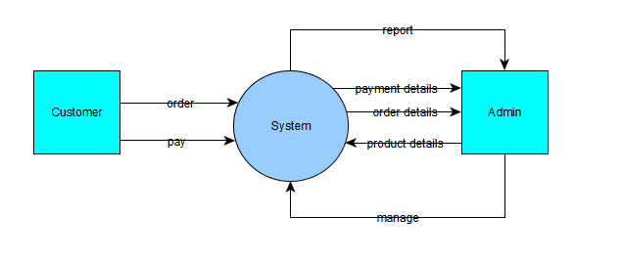

COMMUNICATION OVERVIEW DIAGRAM

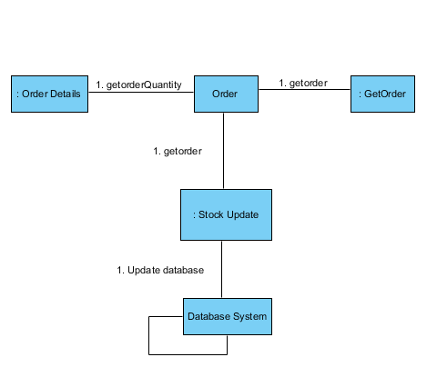

Login Sequence Diagram:

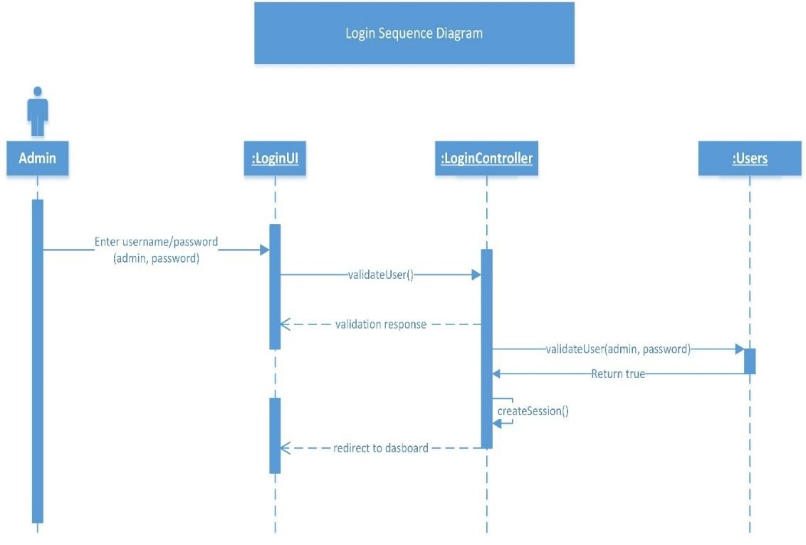

Login Activity Diagram

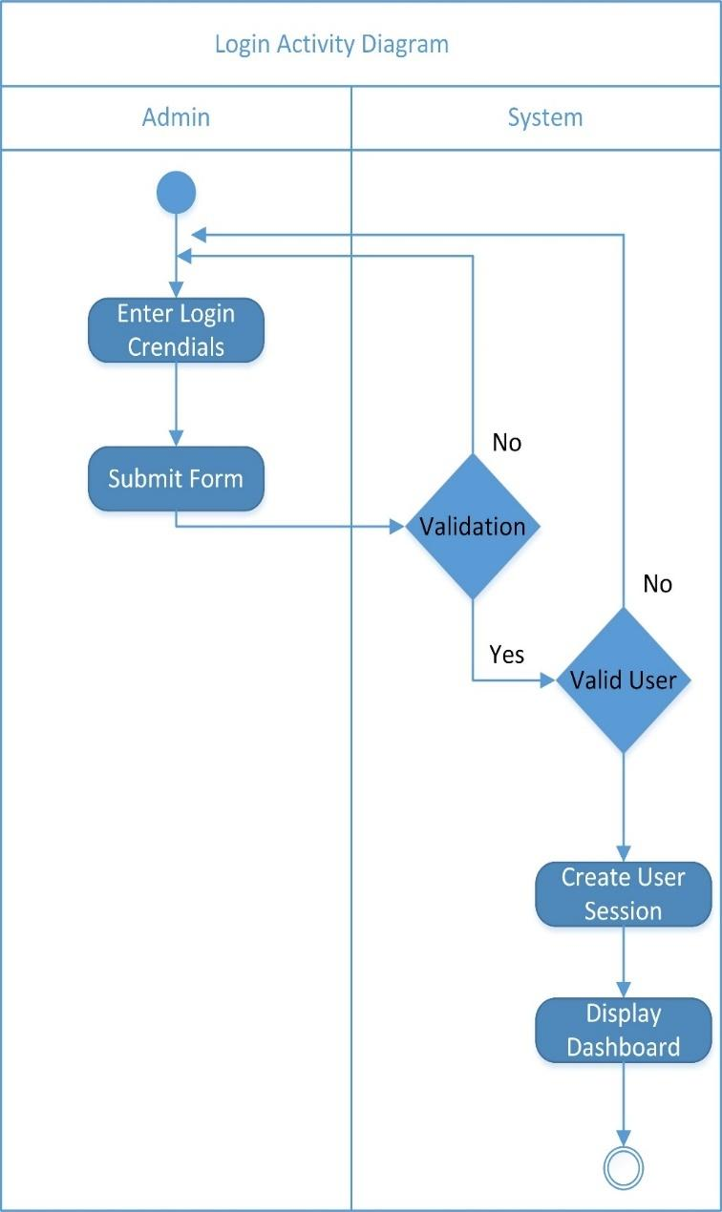

Add Category Sequence Diagram:  
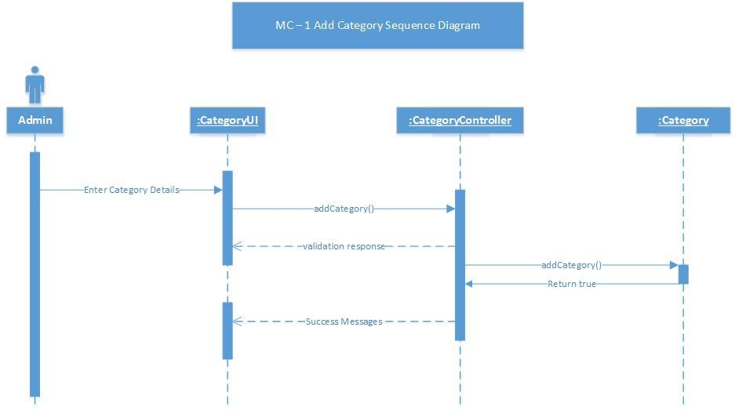

Add Category  
  
Activity Diagram

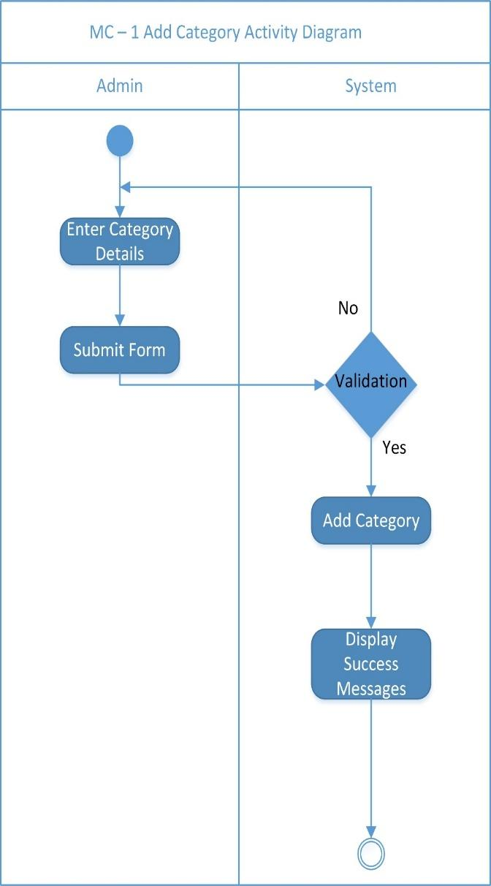

Edit Category Sequence Diagram

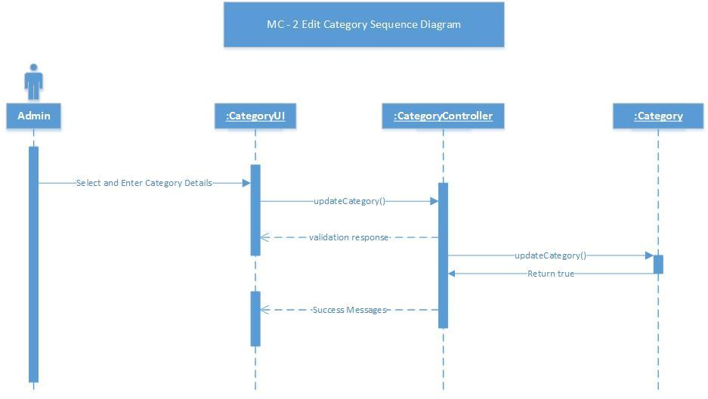

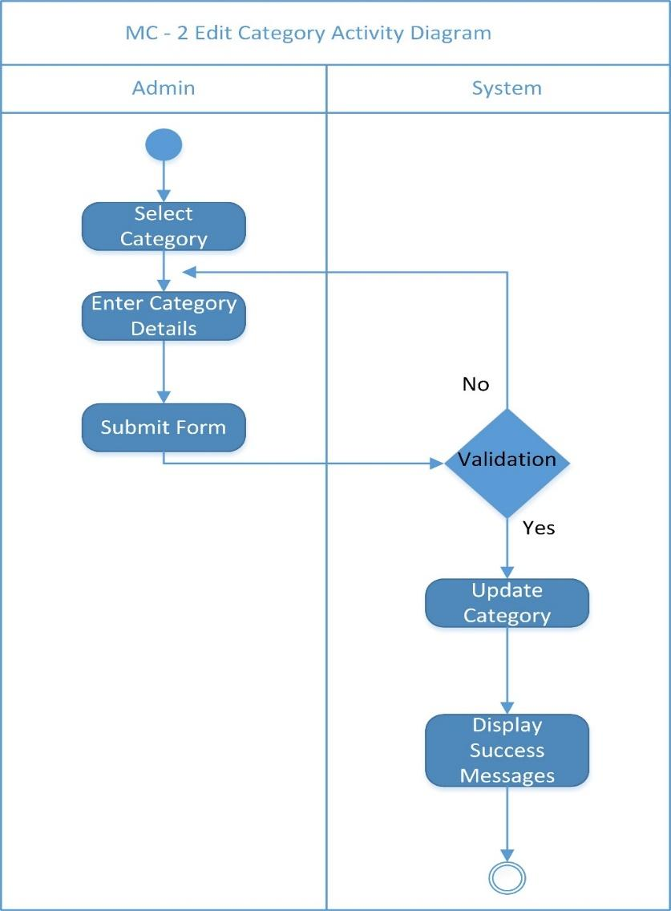

Edit Category  
  
Activity Diagram

Remove Category Sequence Diagram

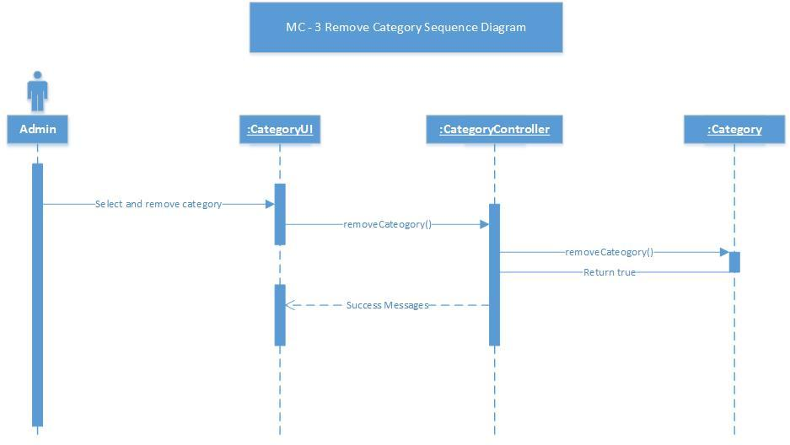

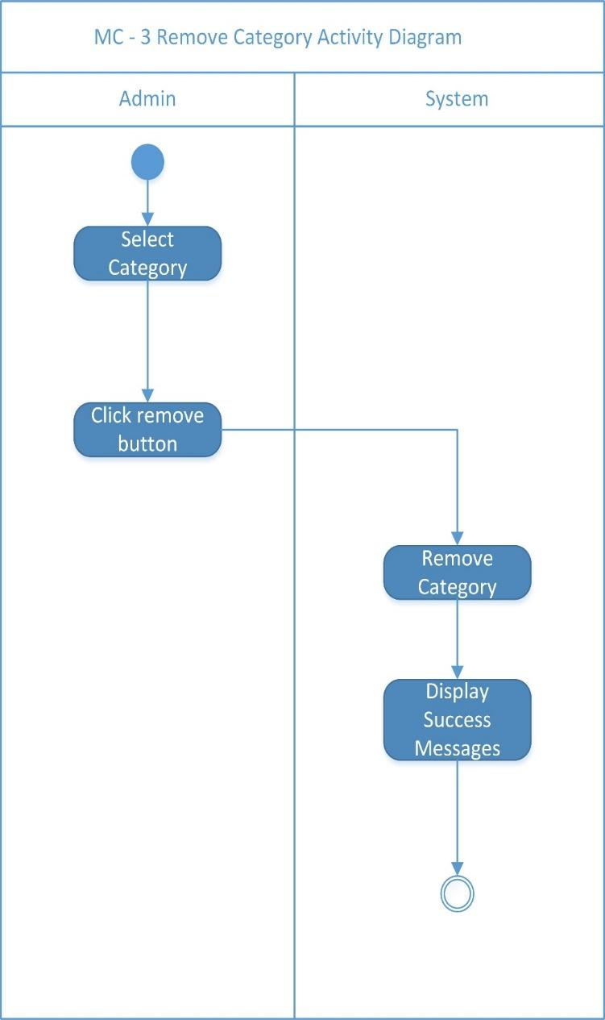

Remove Category  
  
Activity Diagram

Add Product Sequence Diagram

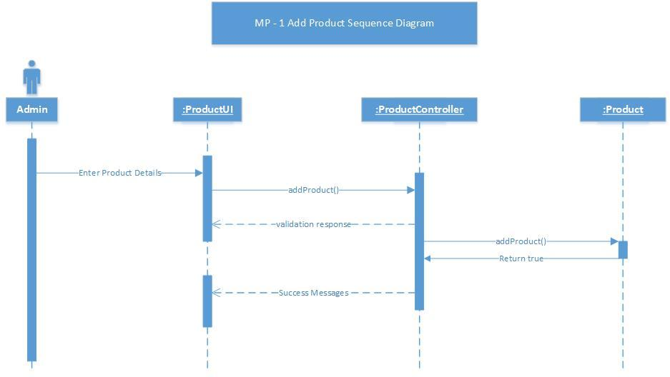

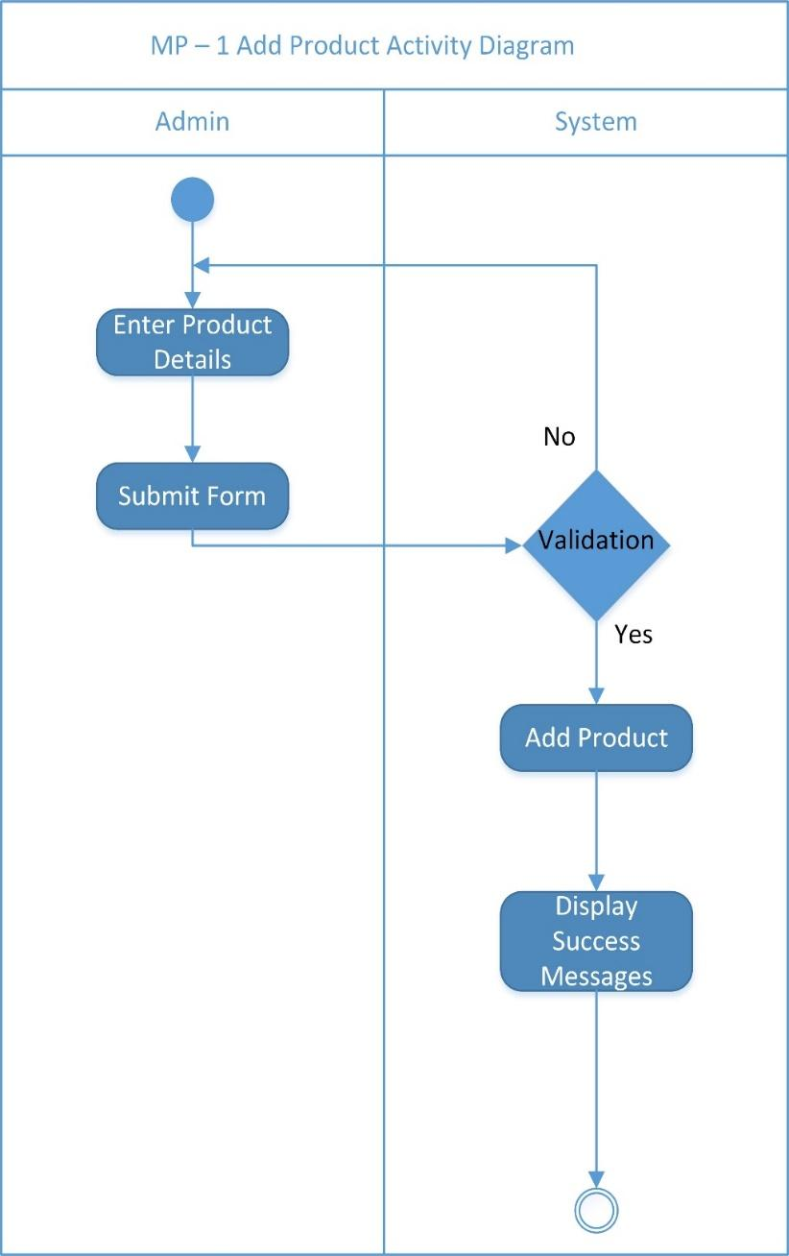

Add Product  
  
Activity Diagram

Edit Product Sequence Diagram  
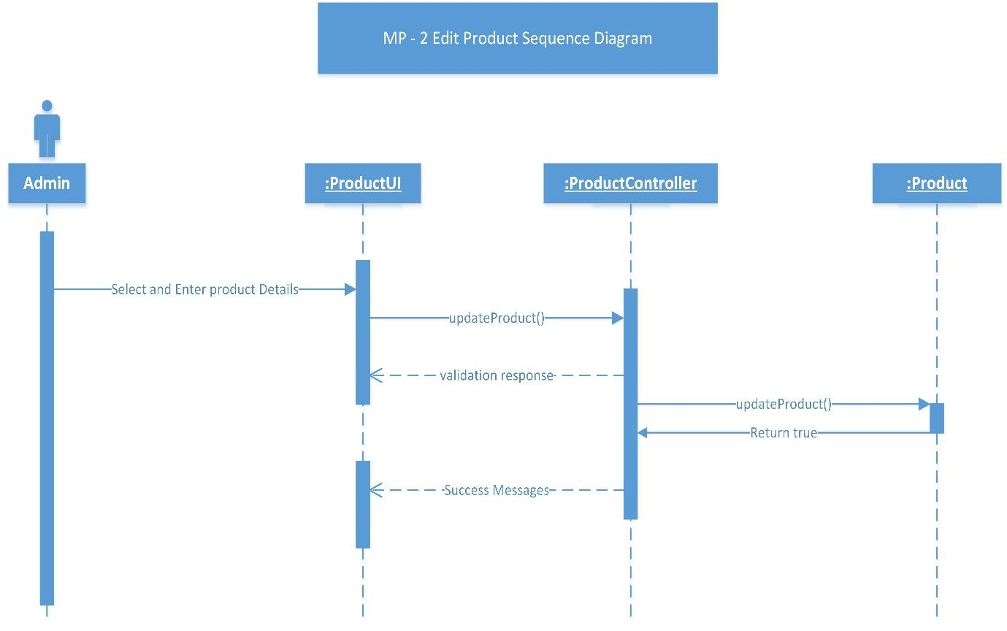

Edit Product  
  
Activity Diagram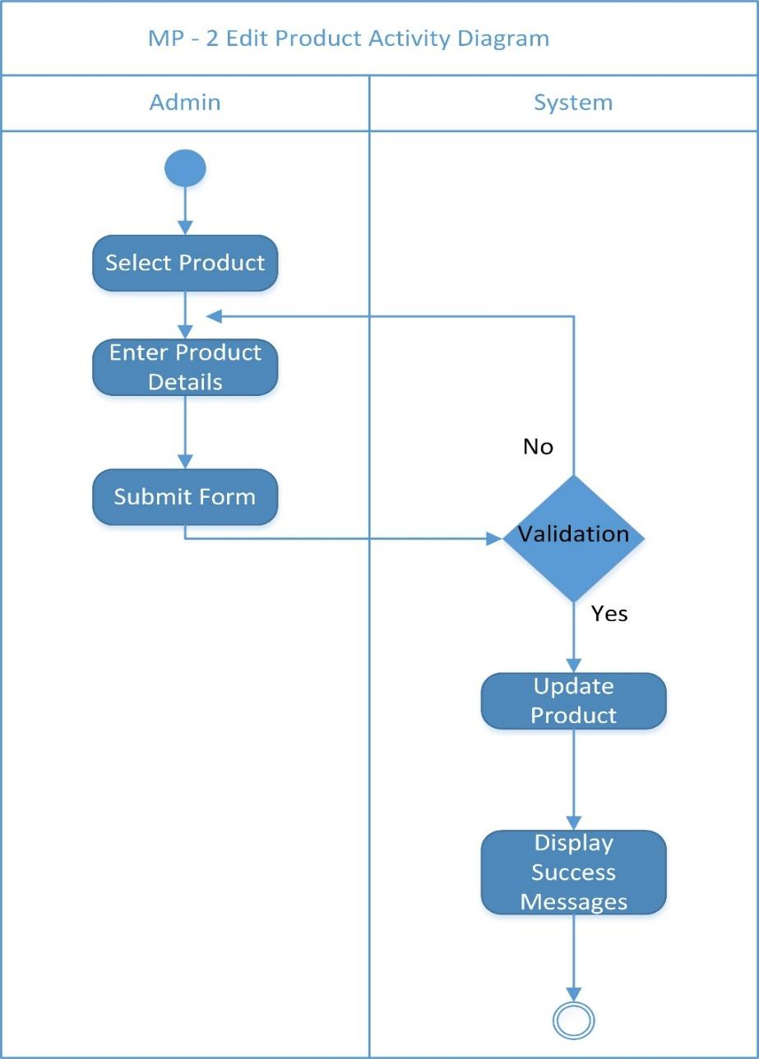

Remove Product Sequence Diagram  
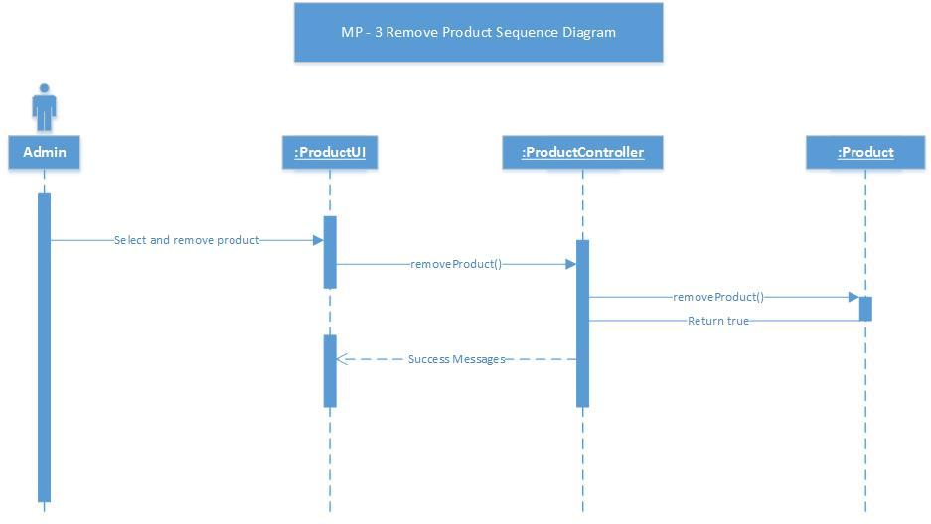

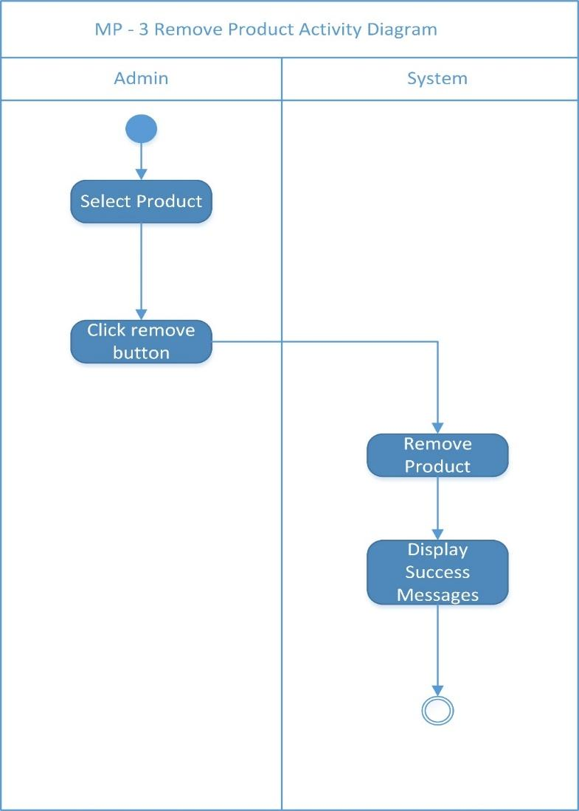

Remove Product  
  
Sequence Diagram

Add Orders Sequence Diagram

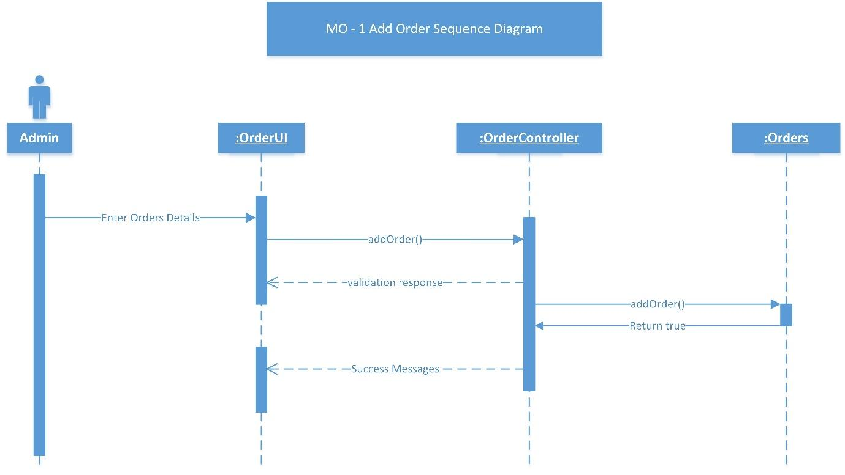

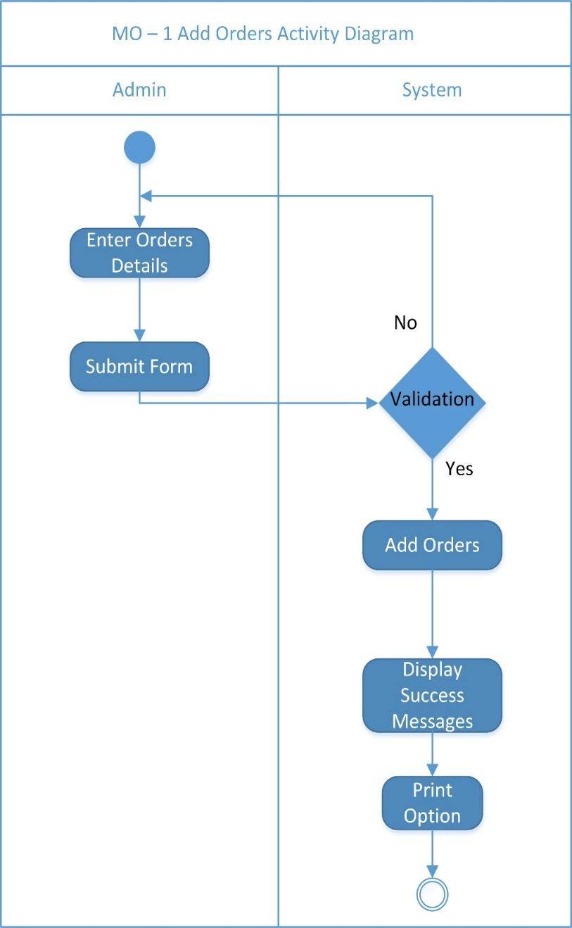

Add Orders  
  
Activity Diagram

Edit Orders Activity Diagram

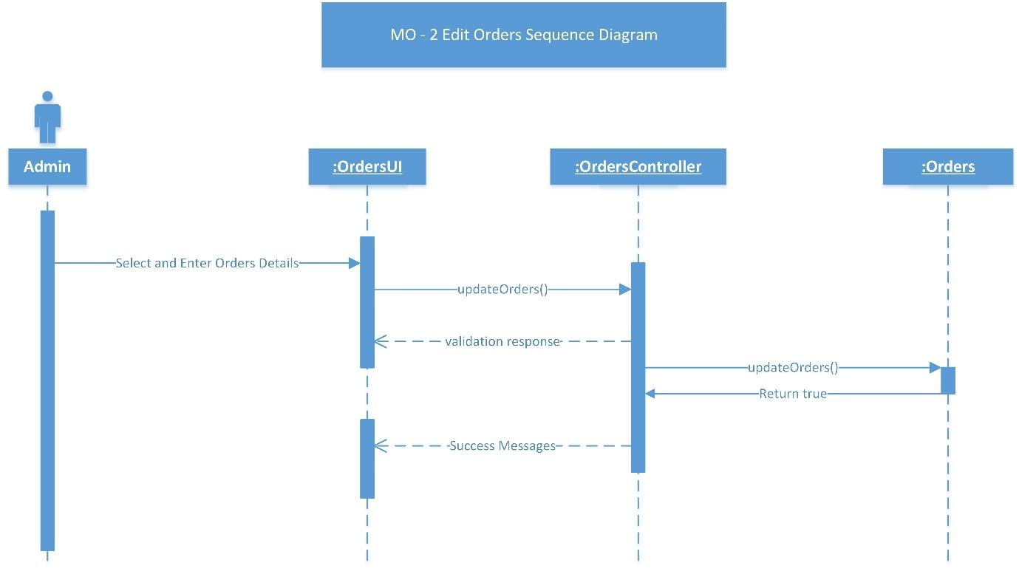  
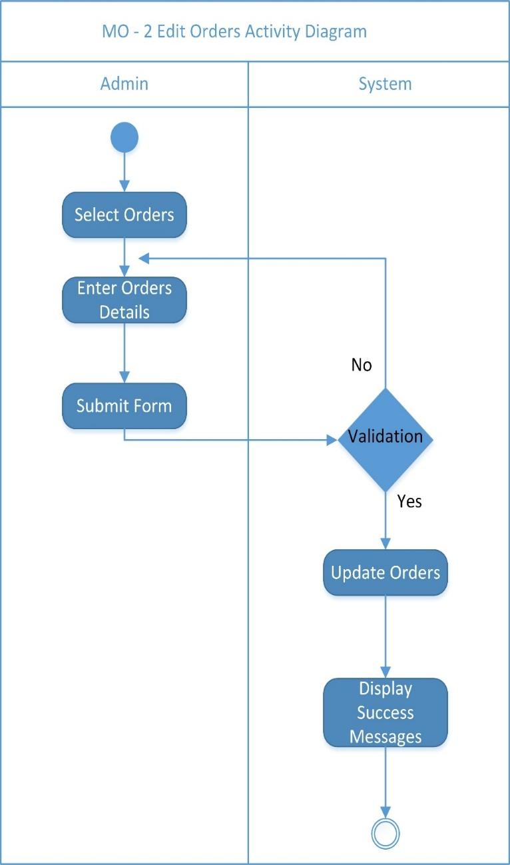

Edit Orders  
  
Activity Diagram

Remove Orders Activity Diagram

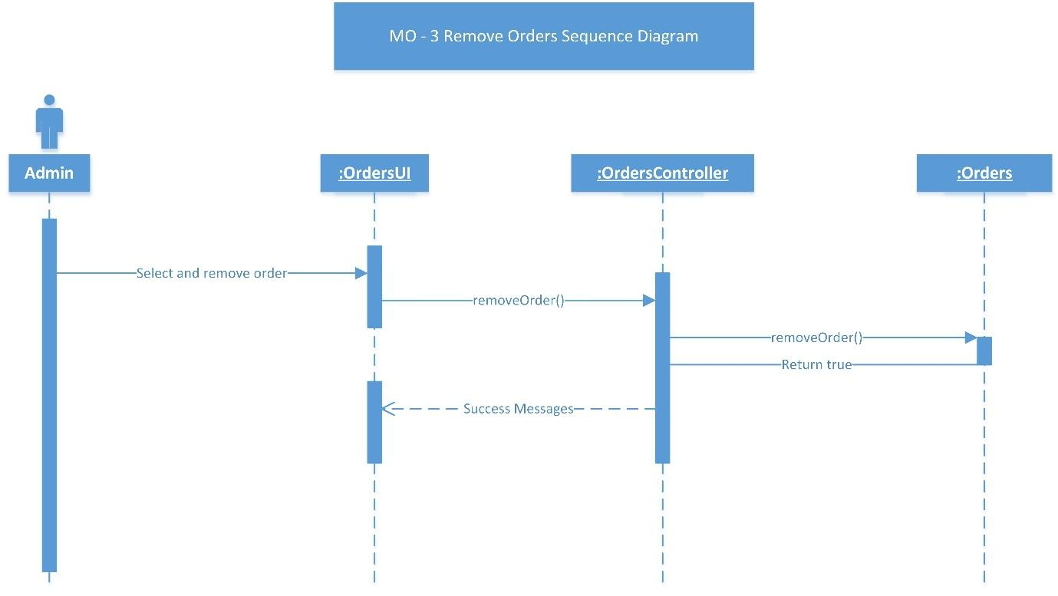

Remove Orders  
Activity Diagram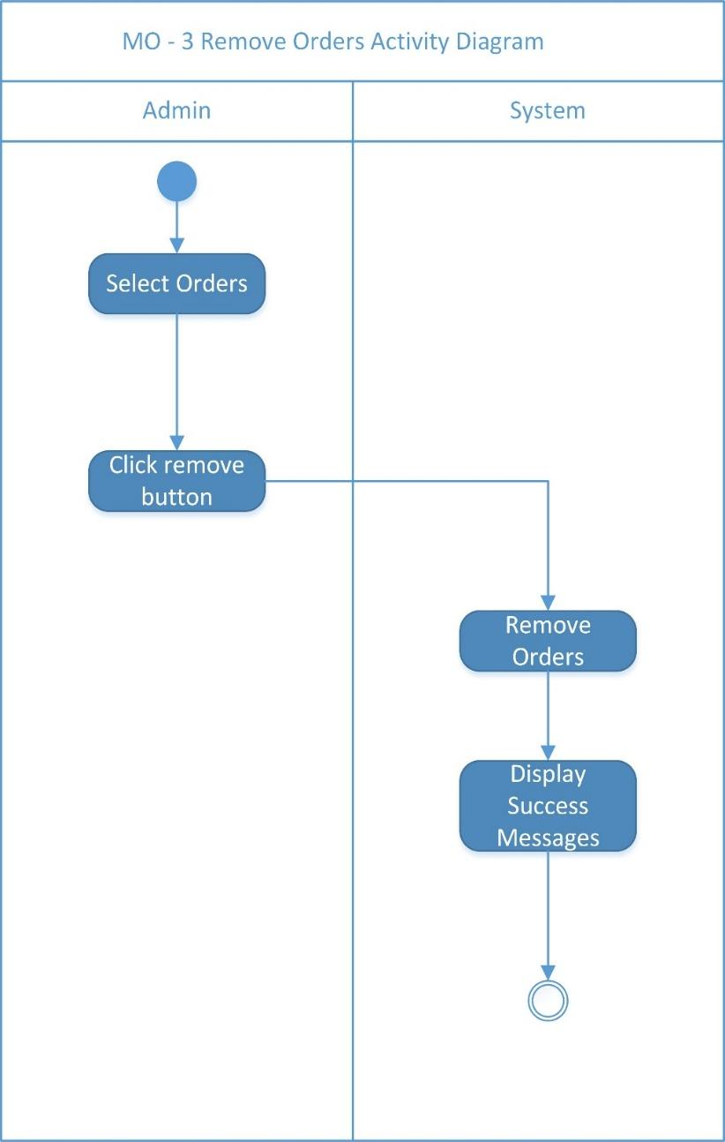

Print Order Sequence Diagram

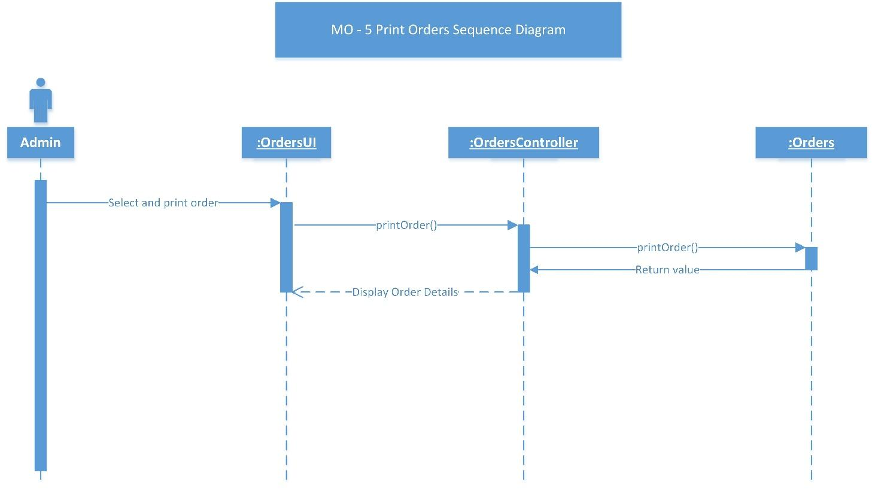

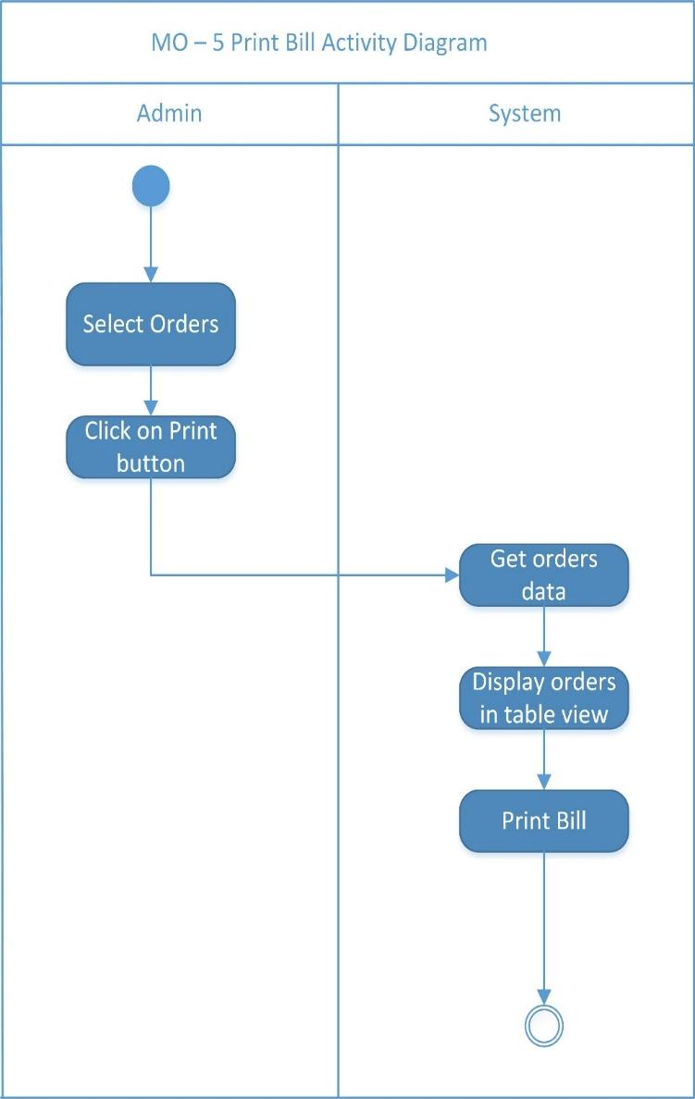

Print Order  
  
Activity Diagram

# Introduction

## Project Context

* We created this inventory system to monitors the levels of inventory and determine the timeline and quantity of orders of Tapsibog eatery. Tapsibog wants to maintain inventories of raw materials, work in development or final products to maximize the profit of the business, including unpredictable raw material delivery time, allowing for production scheduling flexibility or demand variations, this system will help all the employee of Tapsibog to lessen the hassle of managing raw materials. A database used for storing and administering all types of data required for efficient and accurate warehouse inventory management. This may include modules or fields for keeping track of all items and locations, requisitions, back orders, required levels of inventory on hand, reorder points, lead times, inventory error tracking, and more. This type of system may interface with an ERP and other applications.
* Inventory Management must be designed to meet the dictates of market place and support the company’s Strategic Plan. The many changes in the market demand, new opportunities due to worldwide marketing, global sourcing of materials and new manufacturing technology means many companies need to change their Inventory Management approach and change the process for Inventory Control.
* Inventory Management system provides information to efficiently manage the flow of materials, effectively utilize people and equipment, coordinate internal activities and communicate with customers. Inventory Management does not make decisions or manage operations; they provide the information to managers who make more accurate and timely decisions to manage their operations.
* A database used for storing and administering all types of data required for efficient and accurate warehouse inventory management. This may include modules or fields for keeping track of all items and locations, requisitions, back orders, required levels of inventory on hand, reorder points, lead times, inventory error tracking, and more. This type of system may interface with an ERP and other applications.
* Inventory Management must be designed to meet the dictates of market place and support the company’s Strategic Plan. The many changes in the market demand, new opportunities due to worldwide marketing, global sourcing of materials and new manufacturing technology means many companies need to change their Inventory Management approach and change the process for Inventory Control.
* Inventory Management system provides information to efficiently manage the flow of materials, effectively utilize people and equipment, coordinate internal activities and communicate with customers. Inventory Management does not make decisions or manage operations; they provide the information to managers who make more accurate and timely decisions to manage their operations.

## Purpose and Description

* Keep inventory at sufficiently high level
* Perform production and sales activities smoothly.
* Minimize investment in inventory at minimum level to maximize profitability.

## Objectives

* To ensure that the supply of raw material & finished goods will remain continuous so that production process is not halted and demands of customers are duly met.
* To minimize carrying cost of inventory.
* To minimize inventory ordering costs

## Scope and Limitations

A detailed description of initial release:

* The Scope of this project system are the item tracking, inventory managing, logs, and reporting. Item tracking will record all the transactions that have been inputted in the project system. Inventory Managing will edit product details easily. Reporting will show all the records and logs of the transactions. The project will reduce manual works for the employees.

Scope of Subsequent Releases:

If desired, subsequent phases of the Tapsibog Inventory Management System project can be designed and purposed by client that may address future requirements such as:

Limitations and Exclusions:

The scope of work for the Inventory System includes execution, implementation, and knowledge about the system. The main cook will be responsible for the inventory system while the cashier will be responsible for the Point of Sale that is connected to the Inventory System. Each stage of the project will be recorded or logged in the system for the owner so he/she can review, manage or evaluate.

Limitations of work to be completed by the Inventory System project within the agreed upon project scope due to legal, physical, and/or technical reasons are detailed as follows

* Installation of hardware/software other than that defined within the scope of this document.
* Construction or modifications to walls, ceilings, or millwork at installation locations with the exception of mounting brackets as defined within this document.
* Modification to or support of network cabling or interfaces required for installation
* Configuration, testing, or maintenance of Internet Service Provider connectivity.

# Review of Related Literature/Systems

Stakeholder Profiles:

Tapsibog eatery is a business that wants to grow but with the issues that concern Mrs. Kat Castrillo, that is the part where the group wanted to help the owner to improve her business and somehow maximize the profit that she will earn for a greater success of the business and build branches. Our priority is to help Mrs.Castrillo save time and lessen the mistakes of computations, counting and other things that are done manually. It is located at a populated area where business is good but due to its lack of systematic way of business it cannot properly serve customer properly.

* Improved productivity
* Reduced rework
* Cost savings
* Streamlined business processes
* Automation of previously manual tasks
* Ability to perform entirely new tasks or functions
* Conformance to current standards or regulations
* Improved usability or reduced frustration level compared to current applications

# Technical Background

Project Priorities:

The main priority of the business is to keep the level of the supply to its needs, and also, to keep track of the transactions in the business for more transparent transaction between the cashier and the customer, Systematic way of business is what we want to lessen the manpower needed and lessen the expense that does not need.

Business Operating Environment:

The business operation will be in 18 hours (8am – 1am), the system that will be created will be used almost whole day that’s why the group designed this system to be highly integrated and functional

# Methodology, Results and Discussion

## Requirements Analysis

After speaking to the owner of the Tapsibog we found out what are the weakness and strengths of the business, and we come up with the possible solutions that the system could do for them. Most problem that the facility encounter is about recording, retrieving and keeping track of the records of transaction due to its paper-based process which makes it less efficient. With the Tapsibog inventory system the problem that they encounter will be resolved and minimized.

## Requirements Documentation

Solutions to the problem are conducted and process for more effectivity of the system, after speaking to the client he agreed to the solutions that we proposed.

* The system shall have database and user accounts for the cashier and owner itself.
* The system shall have a POS for more effectivity of the business.
* The system shall allow user to view and create on the system
* The system shall allow cook to make the inventory to replenish if the supply is low.
* The system shall display the total of the ordered food.
* The system shall automatically cancel transaction when the customer did not continue with the transaction.
* The system shall have attach image feature for the image of the item in inventory
* The system for the admin side shall only be accessible by the owner.
* The system shall have searching or sorting feature to easily look for records.

## Design of Software, Systems, Product, and/or Processes

Operating Environment:

For the operating environment of the system, the Tapsibog Enrollment System must meet the following minimum hardware requirements: Dual Core 1.6GHz or faster with RAM: 1 gigabyte (GB) (32-bit) or 2GB (64-bit). Regarding the browser, system shall support web browser such as: Mozilla Firefox, Google Chrome.

* **User Classes and Characteristics**

System Administrator / Owner:

* + The system administrator / owner manages the database. the one who will handle the system will be the one to use the system frequently. Also, the system administrator is the only one who can access the backend system and must be knowledgeable on how to use the system and how to manage the database e.g. adding and modifying records.

Cook / Owner:

* + The cook/owner must have the knowledge on creating and managing their account.

Employee:

* + The only interaction of employee with the system is to record their order in the system and the cook will be notified when the order was made.

Assumption and Dependencies:

|  |  |
| --- | --- |
| **Assumption** | **Description** |
| AS-1 | Security and maintenance must take place for the better business process. |
| AS-2 | Less paper-based process for the records of students. |
| AS-3 | The details of every records must be accurately sorted. |
| AS-4 | The user must submit accurate data for the system to generate accurate information. |

|  |  |
| --- | --- |
| **Dependencies** | **Description** |
| DE-1 | The number of data that can be handled will depend upon the capacity of database. |
| DE-2 | The management should be trained and tested in using the system. |
| DE-3 | Accuracy of modification of records depends on the facility’s employee in charge in the system. |
| DE-4 | System performance relies on the facility’s machine |

## Development and Testing, where applicable

Operating Environment:

For the operating environment of the system, the Tapsibog Enrollment System must meet the following minimum hardware requirements: Dual Core 1.6GHz or faster with RAM: 1 gigabyte (GB) (32-bit) or 2GB (64-bit). Regarding the browser, system shall support web browser such as: Mozilla Firefox, Google Chrome.

## Description of the Prototype, where applicable

# Business Requirements

* Track inventory levels
* Track order
* Stock management
* Item identification

**Background**

This paper describes the *Inventory* *System* sufficiently to determine the feasibility and usability of a finished system. The core concept is to track the sale of items from the cash registers with additional features for interpreting the data. It uses a client-server model with a connected database to the Point of Sale. This allows for later expansion while still supporting the targeted small businesses.

## **Business Opportunity**

Manual Inventory control takes a lot of time and more prone to have errors in recording

Order details and inventory supply. Also in computing the sold items, bought supply, and other computations. On the other hand, The Inventory system includes the activities of forecasting and product replenishment. It determines when to order supplies, how much to order and the most effective source of supply for each item in the inventory. This ensures that distributors have the right quantity of the right item in the right location at the right time. The system fits to a restaurant or an eatery who wants to expand, grow and most probably, add branches of their restaurant or eatery.

## **1.3.** **Business Objectives and Success Criteria**

BO-1: Tracks inventory levels

BO-2: Manages orders and fulfillment

BO-3: View Product History

BO-4: See Replenishing Points

SC-1: Have 90% of the customer know if their order is available before placing order to cashier

SC-2: Have only less than 10% of spoilage in the inventory

## Implementation Plan (Infrastructure/Deployment) where needed

## **1.1.** **Vision Statement**

For the Employees who wish for a faster transaction of products and to keep track of food supply of the company’s inventory with papers, The Inventory System that our group will create is a computer-based system for tracking inventory levels and orders. It also has a Point of Sales system is the time and place where a retail transaction is completed. At the point of sale, the merchant would calculate the amount owed by the customer and indicate the amount, and may prepare an invoice for the customer. Unlike from the previous transactions where it is hard to keep track of the inventory and time consuming

## **1.2.** **Major Features**

FE-1: Supply is recorded in the inventory database (including raw items).

FE-2: Order meals from menu are entered in the Point of Sale.

FE-3: Invoice is recorded to the PoS.

FE-4: Inventory count will be deducted based from the order detail.

FE-5: All transactions are logged.

FE-6: User-Friendly User Interface.

FE-7: Client and Server Access.

## **1.3.** **Assumptions and Dependencies**

AS-1: The transaction records have lesser chance to have an error in records.

AS-2: There will less spoilage from the inventory.

AS-3: Records are accurate.

DE-1: If the restaurant has an Inventory System, the employees must fully understand how to use the system.

# 2. Scope and Limitations

## **2.1.** **Scope of Initial Release**

A detailed description of initial release:

* Creation of predetermined user accounts mapped to default administrator roles and non-administrator roles.
* Working inventory and POS systems that caters to the needs of Tapsibog.
* Installation and configuration of software components on Tapsibog’s computer that meets predefined hardware & software requirements.

## **2.2.** **Scope of Subsequent Releases**

If desired, subsequent phases of the Tapsibog Inventory Management System project can be designed and purposed by client that may address future requirements such as:

* Installation and configuration of inventory and POS systems software updates.
* Expansion of the inventory system.
* Creative collaboration to design custom graphics, user interfaces, and/or seasonal themes.
* Installation and configuration of additional network functionalities such as:
  + Content control via remote wireless equipment including laptops and PDA’s.
  + Streaming information to email inboxes, text messages, and/or RSS

## Implementation Results, where applicable

## **Customer or Market Needs**

A Customer would always wish for a fast and smooth service. The system would help

The customers satisfy their need during the transaction with the cashier. Also, when a customer has change for his payment instead of the cashier computing it or using a calculator, the system will calculate the total amount of payment the customer should give then the customer will automatically compute if there’s a change or shortage.

## **Business Risks**

RI-1: The Main Cook might have made a mistake while recording supply count in inventory.

RI-2: Cashier made an error input in the PoS.

RI-3: One error from the system will make the next step to cause an error also.

# Conclusions and Recommendations

The group was able to create and develop a working frontend and backend system to fulfill the needs of the client. For the system side, the interface design was already modified but not finalized yet. The database and forms were already generated and able to search, create, read, update, and delete records we are trying our best to help this business to grow.

# Appendices

Kenneth G. Romero

5712 Pagulayan St. Poblacion Makati City

romerokenneth@yahoo.com

09178220974

|  |  |
| --- | --- |
|  |  |
|  |  |

**Education**

October 2014 – Present Asia Pacific College

#3 Humabon Place, Magallanes, Makati City

Bachelor of Science in Information Technology

Major in Mobile and Internet Technology

June 2010 – April 2012 Mapua Institute of Technology

Gen. Gil Puyat, Makati City

Bachelor of Science in Information Technology

June 2006 – April 2010 Don Bosco Technical Institute of Makati

Chino Roces, Makati City

**Organizations**

2016 Cipher

**Personal Data**

April 21, 1992

Makati City

Filipino

Single

Owen James D. Ylaya

Block 3 Lot 24 Addas Greenfields phase 2 Bacoor Cavite

sica.jungsica16@gmail.com

09273398339

|  |  |
| --- | --- |
|  |  |
|  |  |

**Education**

June 2014 – Present Asia Pacific College

#3 Humabon Place, Magallanes, Makati City

Bachelor of Science in Information Technology

Major in Mobile and Internet Technology

June 2003 – March 2012 Paco Catholic School

1521 Paz Street Paco, Manila

**Organizations**

2016 JISSA

2015 Paco Catholic School Dance Company

**Personal Data**

February 16, 1997

Cavite

Filipino

Single

May include the following:

- Relevant Source Code

- Evaluation Tool or Test Documents

- Sample input/output/Reports

- Users Guide

- Process/Data/Information Flow

- Screen layouts

- Test Results

- Sample Generated Outputs

- Pictures showcasing the data gathering, investigation done (e.g. floor plan, layout, building, etc.)

- One-Page Curriculum Vitae per team member

SCREENSHOTS

Login Screen

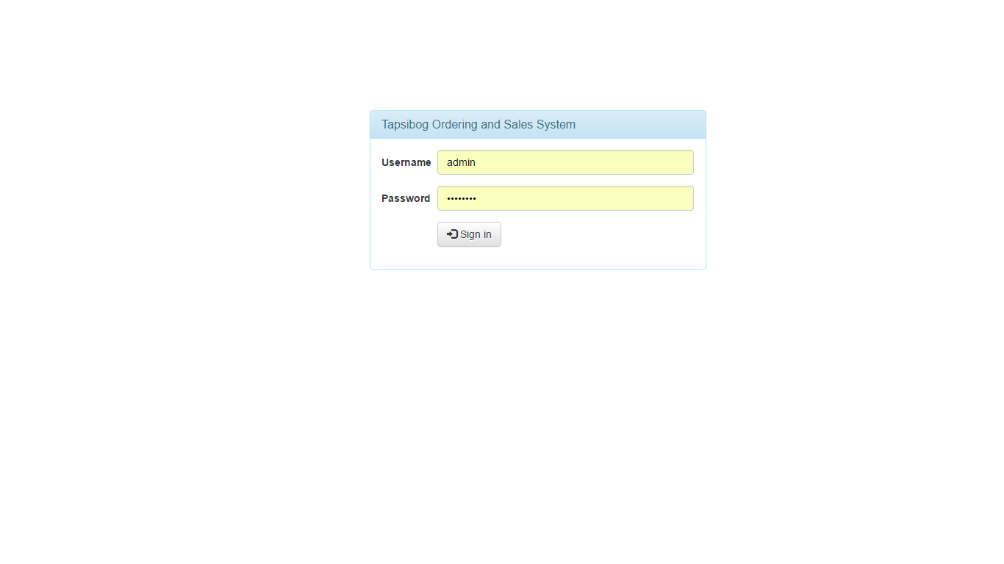

Home Screen  
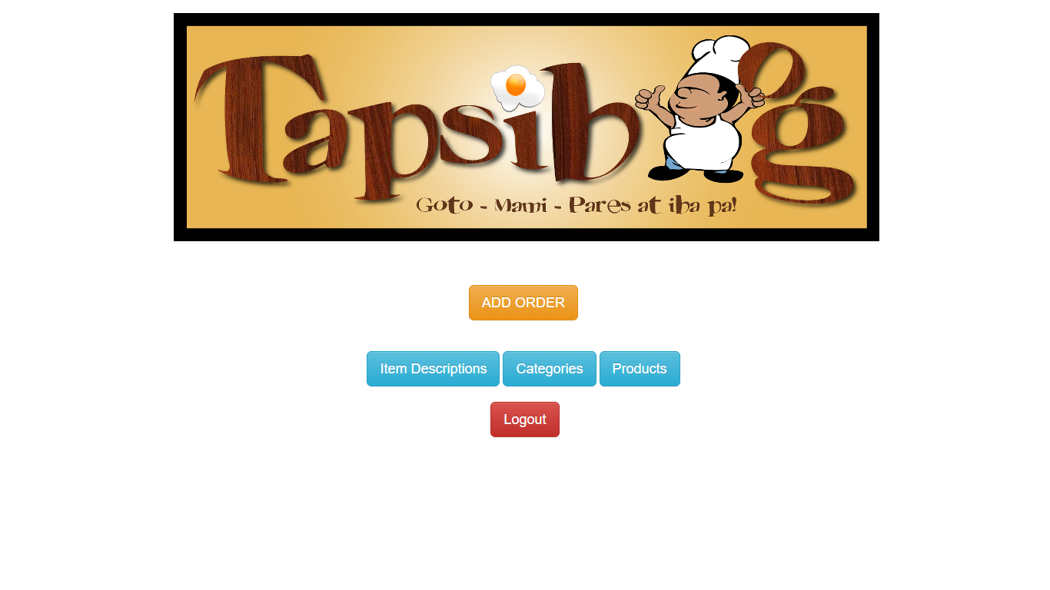

Add Order page

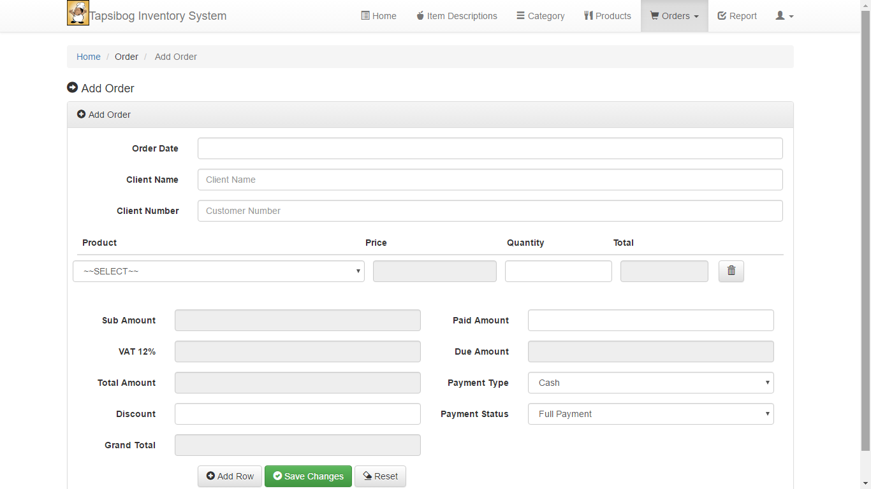

Item Description page

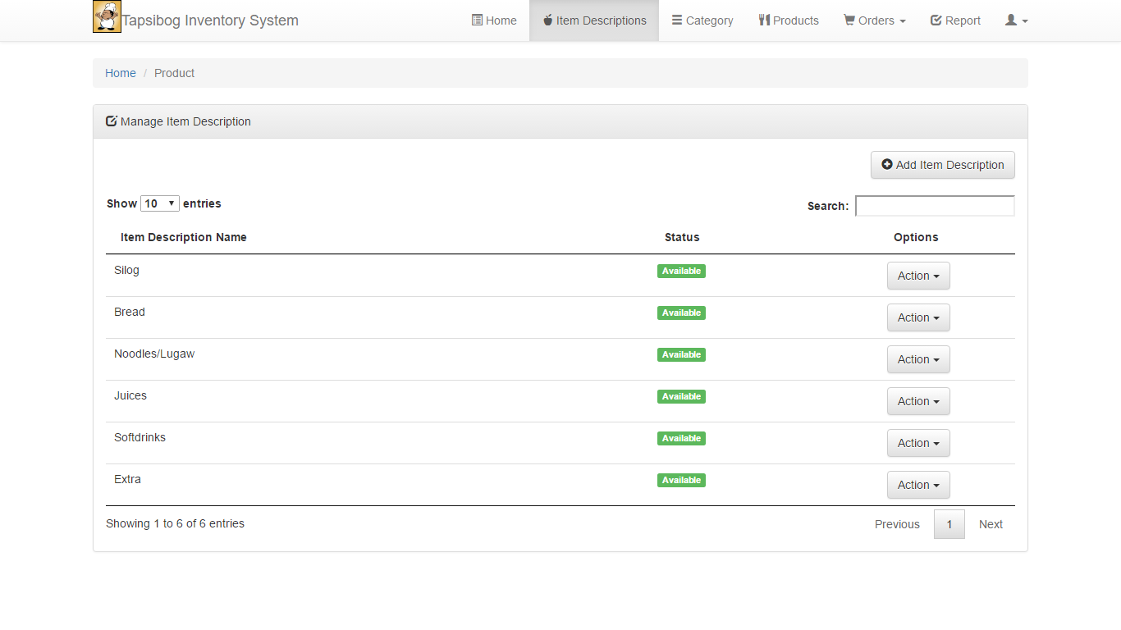

Category page

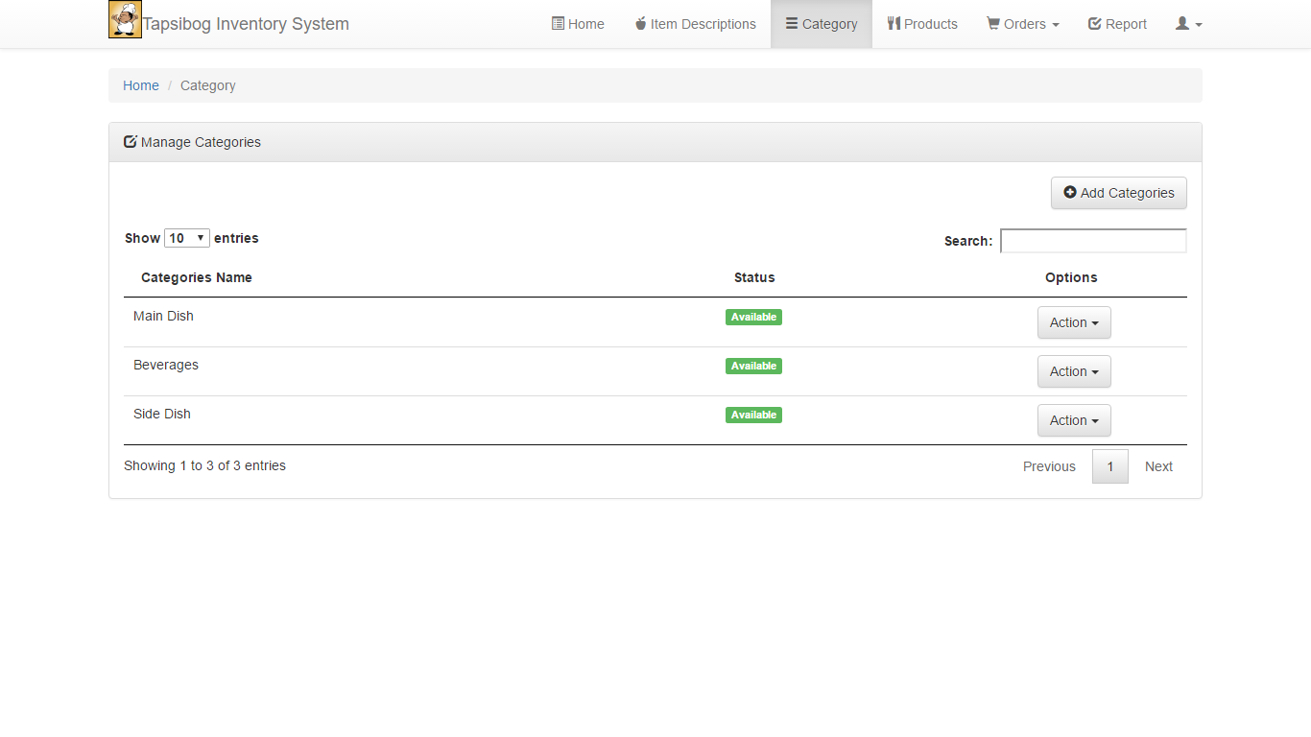

Products page

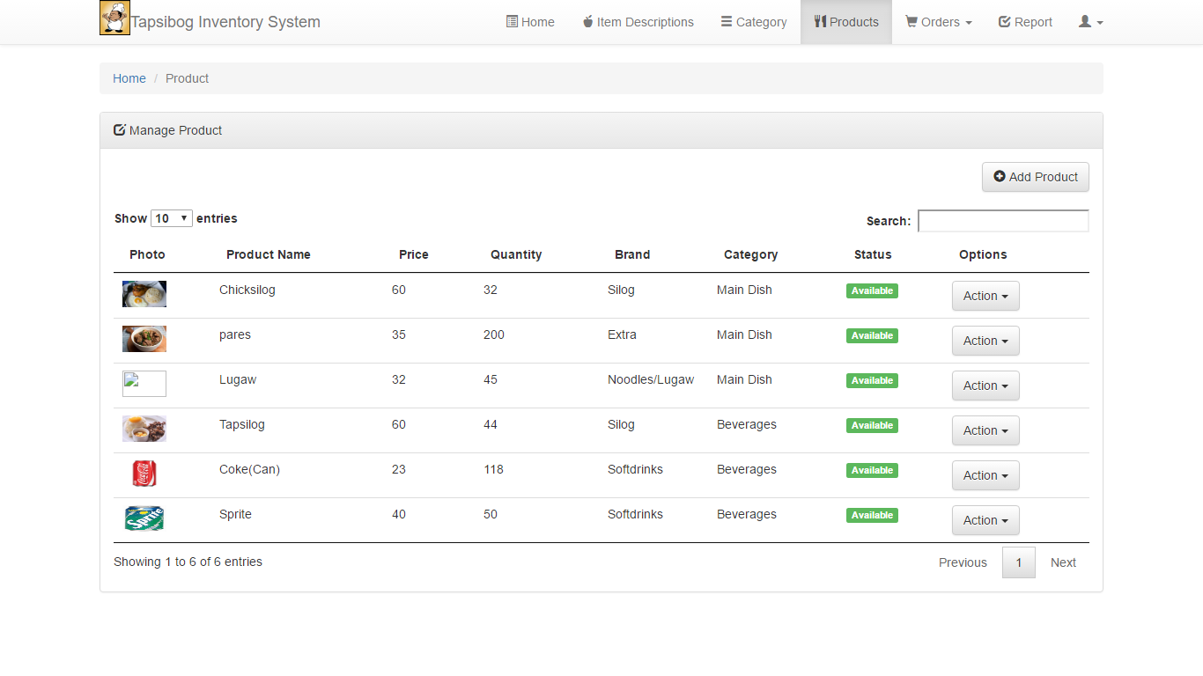

Managing Orders

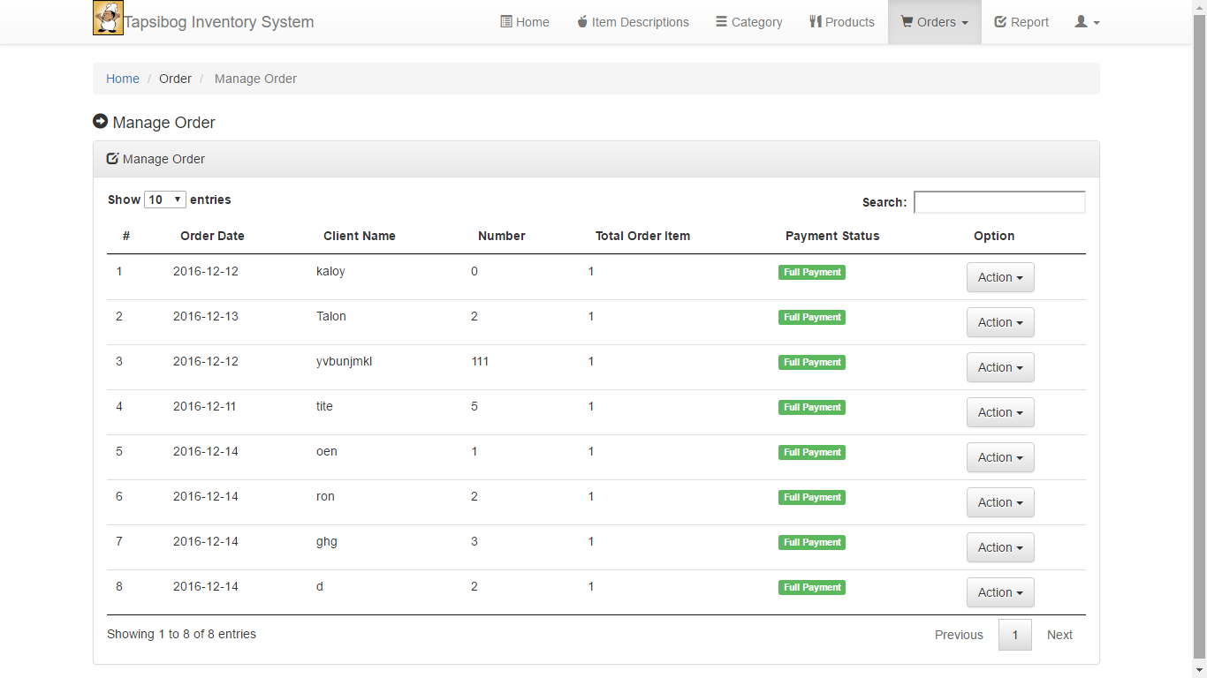

Generate Reports

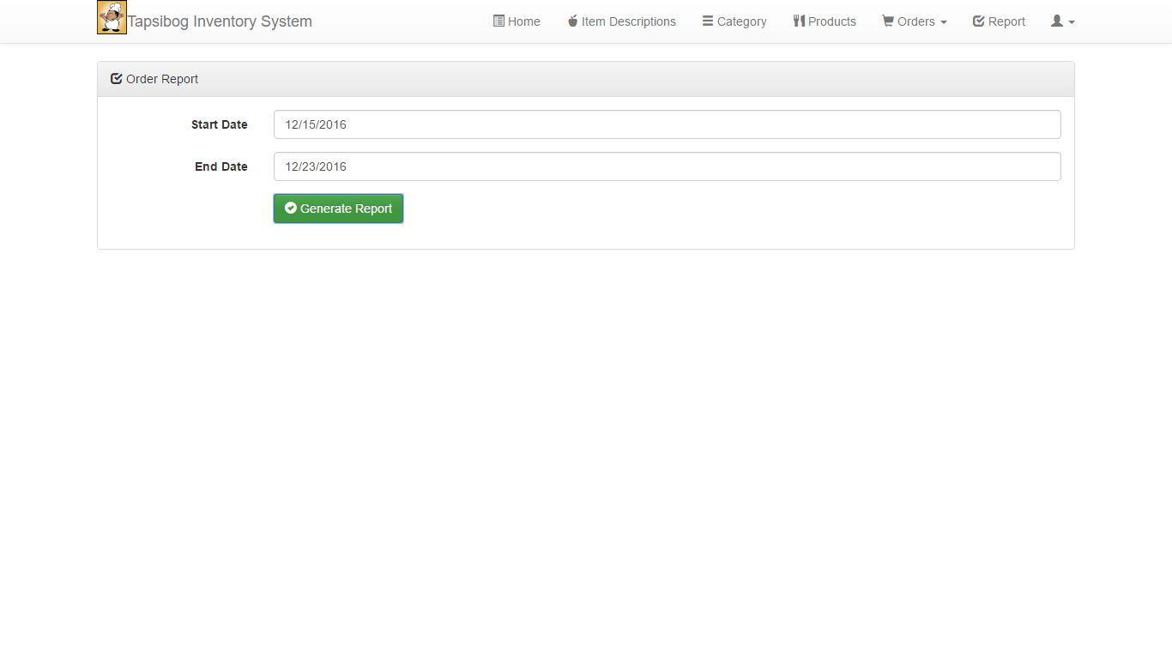

Add product

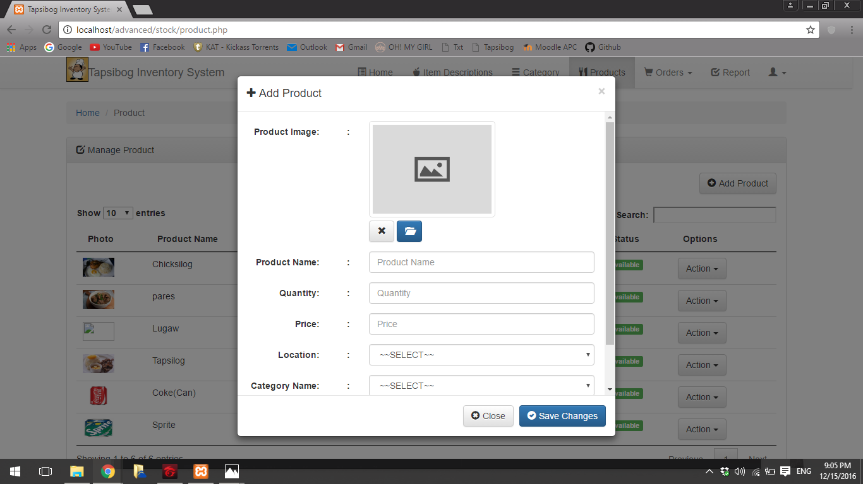

add categories

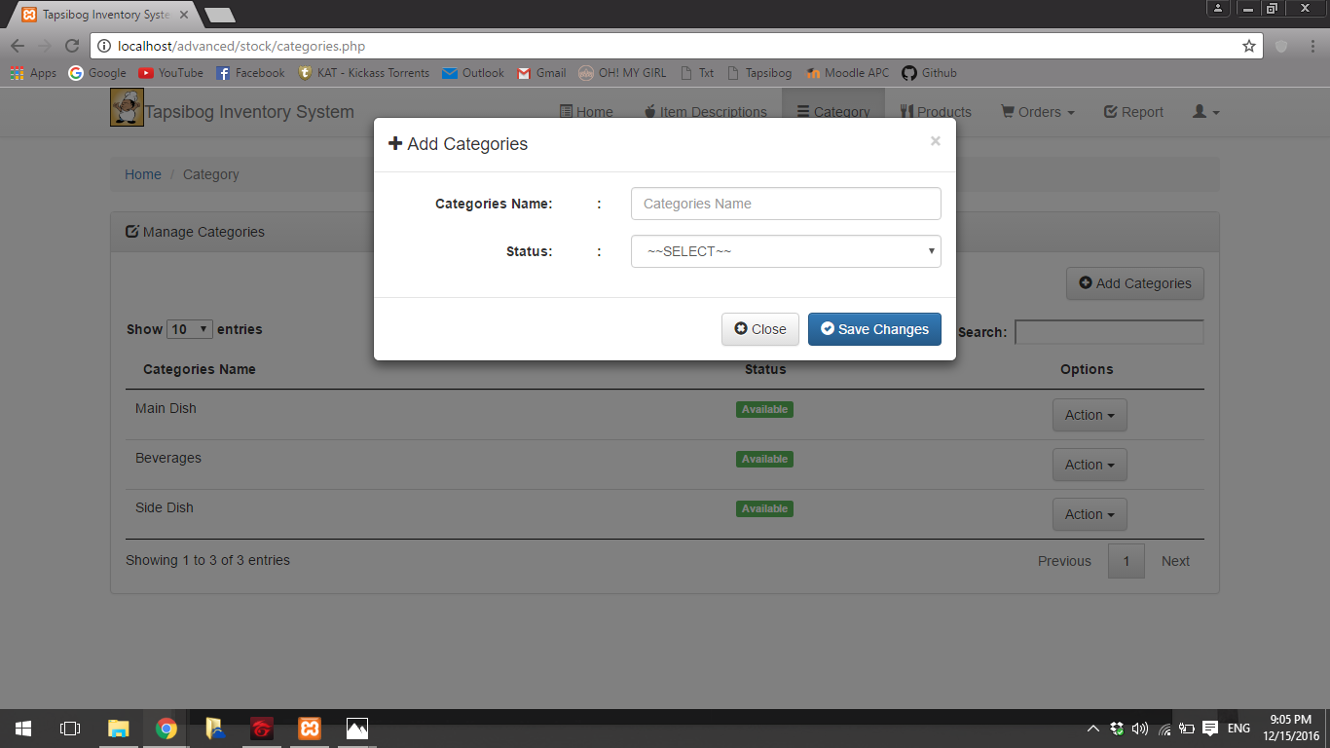

Add Item Description

